Instructions for Preparing

Decision Package Submissions

2014-2016 Biennial Budget



Department of Planning and Budget
August 2013

TABLE OF CONTENTS
Decision Package Overview 1
About the Decision Package Submission 1
What’s new or different this year? 1
Budget Calendar 1
Technical Adjustments vs. Decision Packages 2
Enterprise Priorities and Strategies 2
Enterprise Priorities and Strategies Listing 3
Strategic Link 7
Personal Services 7
Budgeting for New Positions 7
Benefit Rates 8
Nonpersonal Services 9
Detailed Nonpersonal Services Subobject Codes 9
Allowable Nonpersonal Services Convenience Codes 10
Components 11
Nongeneral Fund Revenue Source 11
Rate Adjustments 11
Reports 12
Decision Package Module Instructions 13
Decision Package Module Quick Guides 13
Overview Tab Overview 15
Overview Tab Instructions 15
Narratives Tab Overview 18
Narratives Tab Instructions 18
Budget Summary Tab Overview 19
Budget Summary Tab Instructions 19
Budget Detail Tab Overview 20
Budget Detail Tab Instructions 20
Position Planning Tab Overview 21
Position Planning Tab Instructions 22
Components Overview 25
Components Instructions 25
NGF Revenue Source Overview 26
NGF Revenue Source Instructions 26
Rate Adjustment Tab Overview 27
Rate Adjustment Tab Instructions 27
Decision Package Prioritization Instructions 28
Decision Package Prioritization Overview 28
Decision Package Prioritization Instructions 28
Decision Package Bulk Submit Instructions 29
Bulk Submit Overview 29
Bulk Submit Instructions 29

Decision Package Overview

About the Decision Package Submission
This package provides guidance and instructions for the submission of decision packages, including technical adjustments for the 2014-2016 biennium due to DPB by September 16, 2013.
You will be using the following modules in the Performance Budgeting System to complete this submission: 1) Decision Packages, 2) Decision Package Prioritization, and 3) Decision Package Bulk Submit to DPB. These modules can be found on the “Operating Budget” menu on the Performance Budgeting system work tray/main screen.
Detailed instructions on the use of the Performance Budgeting system modules are included at the end of this package. However, this package also highlights some topics you should pay closer attention to such as personal services, non-personal services, linkages to Commonwealth enterprise strategies, linkages to objectives and measures, adjustments to nongeneral fund revenues, and allocation across components.
What’s new or different this year?
- Linking to Commonwealth Enterprise Strategies. While enterprise strategy linkages were included in the decision package module last year, agencies were instructed at that time to skip over that field. This year, if a decision package applies to an enterprise strategy, you should complete this information. More details are included later in these instructions on enterprise strategies.
- Position Planning Grid Changes. A small change has been made in the position planning grid that may be helpful, especially when completing position only requests. Specifically, you now have the option to select “not budgeting by role or position” in the decision package position planning grid which will simplify the entry of authorized position information. In this view, you will only need to enter the program/service area, fund detail, salary subobject, and the number of authorized positions being requested. However, if you want to use the position planning grid to help cost-out the dollar amounts associated with new positions, you should continue using the “budget by role” or “budget by position” options.

Budget Calendar

For a complete view of the budget calendar, please visit the DPB Web Site or go directly to http://dpb.virginia.gov/forms/20130426-2/BudgetCalendarAgency.pdf.

Technical Adjustments vs. Decision Packages

Please note that technical adjustments are considered to be just one category of decision packages. As such, you will use the decision package module to submit technical adjustments as well as any non-technical decision package you would like to propose. You should not attempt to use the old technical adjustment module to enter your technical adjustment decision packages. This module is being discontinued. If you intend for a budget request to be considered as a technical adjustment, you should categorize it as “Technical Adjustment” in the “Category” field of the decision package “Overview” tab.
A non-technical decision package is a proposal to modify your agency's budget or to modify language in the Appropriation Act that results in a new initiative, change in policy, or a significant budgetary impact. Each decision package should address one budget action only. Each action should be a discrete unit that can be evaluated on its own merit independent of any other proposals.
A technical adjustment is a proposal to modify your agency’s budget that does not involve changes in policy or significant budgetary impact. Technical adjustments are very similar to base adjustments with respect to items such as the removal of one-time costs; the transfer of dollars or positions between programs or service areas, accounting for additional nongeneral fund revenues that involve no policy changes, and accounting for an increase in position level to reflect actions already approved administratively.
If you are not sure whether or not a request should be categorized as a technical adjustment or submitted under a non-technical category, contact your DPB budget analyst for guidance. Otherwise, the request should be submitted as a non-technical decision package.

Enterprise Priorities and Strategies

Enterprise priorities and strategies provide agencies an opportunity to link budget decision packages to the priorities and strategies of particular significance to the Commonwealth.

As you develop your agency’s budget decision packages, consider whether any of your requests have a relevant link to the enterprise strategies. If they do, please select the most appropriate item in the “Enterprise Strategy” drop down menu in the decision package module. If there is no relevant link to the enterprise strategies, you should not make a selection. A list of enterprise priorities along with associated enterprise strategies is shown in the next several pages. Look through this list to see if any of your decision packages match with any of these strategies.
Enterprise Priorities and Strategies Listing

Business Climate & Economic Development
Enhance and promote Virginia’s competitive business climate to increase opportunity for all Virginians and assure that Virginia is seen as the top state for business in the nation.
- Identify a series of achievable, innovative solutions to help create jobs and grow Virginia’s economy.
- Advance Virginia’s existing businesses and attract new businesses to the Commonwealth.
- Promote economic development efforts in distressed communities across the Commonwealth to bring new jobs and opportunities, and reduce economic disparity among the various regions.
- Improve economic, agricultural, tourism, and workforce development efforts through regional collaboration.
- Competitively promote Virginia’s inherent attributes domestically and internationally.
- Ensure that regulations are not overly burdensome to business.
- Enhance the “Virginia Business One Stop” website by increasing the information, resources, and assistance available.
- Increase tourism and film and video production in the Commonwealth.
- Promote small business and entrepreneurship.
- Support development of all of Virginia's energy resources, including the use of conservation and efficiency measures.
- Expand the energy production and generation infrastructure to reduce Virginia's reliance on imported energy and ensure that Virginians have access to adequate supplies of reasonably priced, reliable electricity, natural gas, and transportation fuels.
- Educate the public about Virginia’s energy production and consumption, its effect on our economy, and how Virginians can use energy more efficiently.
- Strengthen the Commonwealth’s relationship with the Department of Defense and other federal government leaders and make it easy for them to establish and conduct operations in Virginia.
- Be recognized as the most military-friendly and veteran-friendly state in the nation by active duty and retired military personnel, veterans, and their families.
- Support further development and commercialization of emerging and innovative technologies through engagement with Virginia’s research universities.
- Distribute comprehensive information on the Commonwealth's broadband assets.
- Use technology to support and enhance economic development and job creation.
- Leverage and strengthen modeling and simulation and cyber security industries.
- Encourage the purchase and use of Virginia’s agricultural and forestry products and specialty foods, particularly through the Virginia’s Finest and Virginia Grown programs.
- Expand Virginia’s presence for agricultural and forestry products in developed and emerging markets such as China, Europe, India, and Central America.
- Remove barriers to trade for Virginia’s agricultural and forestry products.
- Recruit agribusiness and businesses that can serve ancillary purposes to Virginia’s agricultural and forestry sectors.

Workforce
Develop Virginia's workforce development system as a collaborative enterprise that strategically prepares individuals for employment in high demand occupations.

- Establish career pathways as a model and driver for increasing collaboration between education and workforce development programs.
- Expand Virginia's pipeline of workers for key industry sectors through career pathways systems.
- Increase attainment of education and workforce credentials valued by economic development and employers.
- Strengthen data and reporting for Virginia's Career Pathways programs.

Housing
Develop a clear and consistent housing policy.
- Prevent and reduce homelessness.
- Respond to emerging foreclosure and housing market recovery issues.
- Facilitate the expansion of affordable housing options.
- Promote sustainable communities.
- Streamline housing-related regulations.

K-12 Educational Improvement
Improve educational success for Virginia’s kindergarten through 12th grade school population.
- Empower Virginia's excellent teachers.
- Increase the level of state support and guidance in the development of charter schools in Virginia to ensure that local school boards receive quality charter school proposals.
- Facilitate the establishment of college laboratory schools.
- Create a new framework for virtual schools and online instruction designed to expand options for students while ensuring quality and alignment with the Commonwealth’s academic standards.
- Ensure student literacy and Algebra readiness.
- Increase focus on Science-Technology-Engineering-Math-and-Health (STEM-H) education among secondary students.
- Foster school improvement through innovative approaches.

Enterprise Priorities and Strategies Listing (continued)

College Degree Attainment
Significantly increase college degree attainment in the Commonwealth; award 100,000 additional associate and bachelor’s degrees by 2025.
- Establish a public-private partnership for Science-Technology-Engineering-Math-and-Health (STEM-H)education that develops and implements strategies toward increasing access to STEM-H education and future career opportunities.

Educational Pipeline
Strengthen coordination among education systems to optimize successful student transitions, thereby improving overall achievement.
- Implement a multi-agency longitudinal data system to evaluate student outcomes from preschool through college.
- Facilitate successful transitions between secondary and post-secondary education and careers.
- Support the evolution of the Career Pathways system.

Virginia Health Reform Initiative
Go beyond federal health reform and recommend other innovative health care solutions to provide access to appropriate and affordable health care in an economically responsible manner. Ensure that meaningful reform, including Medicaid reform, is achieved throughout the Commonwealth through approaches that positively impact the health care delivery system, while reducing costs and improving quality.
- Work with the federal government on the implementation of a health benefit exchange.
- Implement Medicaid expansion.
- Pursue Medicaid-funded care coordination models for additional geographic areas, clients, and services.
- Develop a health innovation center for the Commonwealth to advance the Commonwealth's position as a national leader in individual health, community health, health care, and economic growth.
- Enhance the capabilities of the health workforce.

Children and Family Services
Improve child and family outcomes by designing a system of individualized services and community-based support and finding permanent families and family connections for children in foster care or at risk of coming into foster care.
- Refine goals for children in foster care or at risk of coming into foster care and develop a data set for a dashboard to monitor progress toward achievement of the goals.
- Explore more effective contracting to improve partnerships with private sector providers so that the appropriate service is consistently delivered at the right cost.
- Develop and strengthen an accessible array of community-based services and supports across the Commonwealth to reduce the need for more intensive levels of service or to shorten the length of stay when placement is required.
- Re-examine the structure of the State Executive Council of the Comprehensive Services Act.
- Reverse the trend of obesity and improve nutrition to protect the health and well-being of Virginia’s children and their families.

- Develop a system-wide approach to strengthening children's services with a focus on reducing the number of children in foster care or at risk of coming into foster care.
- Develop a system-wide approach to strengthening families with a focus on reducing non-marital births, connecting and reconnecting fathers with their children, and encouraging the formation and maintenance of safe, stable, intact, two-parent families.

Community-focused System of Care for People with Intellectual Disabilities
Promote the highest possible level of participation by people with intellectual disabilities in all aspects of community life.
- Assist individuals who currently reside in training centers to transition to appropriate community settings.
- Establish specialized outpatient medical, behavioral, and dental supports in community-based settings to serve individuals with developmental disabilities.
- Establish a crisis intervention and stabilization system for individuals with developmental disabilities.

Enterprise Priorities and Strategies Listing (continued)

Enterprise Application Re-engineering
Medicaid Information Technology Architecture (MITA) Project - Transform the Medicaid Management Information Systems (MMIS) into an enterprise-wide backbone architecture capable of supporting tomorrow’s Medicaid need through Health Information Technology (HIT), Electronic Health Records, Personal Health Records, Health Information Exchange, and Master Data Management.

- Implement the Customer Facing and Worker Social Services Portal.
- Implement the Enterprise Data Management system.
- Establish foundational enterprise components and environments, including a business rules engine and a workflow engine (enterprise service bus).
- Establish foundational business services (technical infrastructure).

- Complete MITA Care Management Business Area projects to develop needed interfaces.
- Complete MITA Member Management Business Area projects to develop needed interfaces.

Homeland Security & Emergency Preparedness
Ensure that Virginia is always prepared to address threats to the safety and security of the Commonwealth and its citizens and to respond rapidly and efficiently to emergencies.
- Keep current a National Infrastructure Protection Plan (NIPP) for Virginia to identify, prioritize, assess, and protect Virginia's critical infrastructure and key resources.
- Develop a culture of awareness and preparedness throughout Virginia’s state agencies and academic institutions.

- Review emergency and terrorism plans, including the Commonwealth Emergency Evacuation Plan.

Violent Crimes
Address intrastate and interstate public safety issues related to major crimes, gangs, terrorism, drug dealers and domestic violence.

- Develop a plan to address gangs at state and regional levels to include community awareness, education, prevention, intervention, suppression, and re-entry.
- Work with agencies within and outside the Office of the Secretary of Public Safety to review services, identify gaps, and develop a plan to address issues.
- Engage in effective outreach to surrounding states and the District of Columbia to address interstate public safety issues such as gangs, terrorism, probation violations, human trafficking, drug distribution, and Internet crimes.

Adult & Juvenile Offender Re-entry
Develop an operationally strong and secure system and culture of re-entry to enable offenders to succeed upon release. Provide incarcerated juveniles with an environment that promotes character, taking responsibility for one’s actions, and success upon release.
- Assess the Department of Juvenile Justice’s and Department of Corrections' efforts to address re-entry and conduct a review of juvenile facilities and programs.
- Develop programs and work groups to focus on re-entry for veterans, juveniles, and women.

- Within the Department of Corrections, standardize evidence-based practices to promote offender progress and successful re-entry.

Substance Abuse Prevention

Coordinate with Public Safety agencies to use state-of-the-art crime prevention efforts in critical areas such as underage drinking, drunk driving, drug abuse, teen violence, domestic violence, bullying, and other areas related to substance abuse.
- Coordinate with all relevant public safety agencies to ensure that Virginia is engaged in state-of-the-art crime prevention efforts related to substance abuse.

Enterprise Priorities and Strategies Listing (continued)

Chesapeake Bay Restoration
Work with other Atlantic coast states and continue responsible policies to protect and improve the health of the Chesapeake Bay, including making every effort to meet the goals for nutrient reduction outlined in the Chesapeake Bay agreement signed in 2000.
- Implement the most effective practices to reduce nutrient levels in the Chesapeake Bay.
- Develop Phase II of Virginia’s Watershed Implementation Plan.
- Encourage and facilitate the use of best management practices employed by farmers and agribusiness.
- Increase the amount of agricultural acreage under agricultural management plans to 60 percent.

Land Conservation
Work toward a goal of preserving an additional 400,000 acres of land by 2014.

- Continue to use easements and tax credits for land conservation.
- Encourage and secure purchase of development rights of working farmlands for land conservation.

- Preserve land by ensuring easements held by large easement holders allow for a full array of agricultural and forestry activities to take place.

Seamless, Multimodal Transportation System
Ensure that Virginia will have a coordinated system of roads, rails, ports, transit, bicycle, pedestrian, and aviation resources that provides integrated and efficient options that meet citizen, visitor, and business transportation needs. The system will provide connectivity across all transportation options.

- Enhance the intermodal transportation system.
- Develop unified and collaborative transportation planning and implementation processes.
- Emphasize sustainable and stable financial support.
- Be an innovative pacesetter in technology, environmental protection, and system management.
- Maintain a strong customer focus to address travel and business needs through a multimodal system that will be affordable, dependable, and easy to use.
- Ensure that the transportation system promotes and supports economic opportunity.

Transportation System Safety Improvement
Improve safety across all modes of transportation.
- Increase coordinated safety and security planning.
- Improve safety operations and services.

Internal Controls and Financial Stewardship
Ensure the long-term financial security of the Commonwealth by providing effective and efficient financial management, planning, and budgeting.
- Maintain Virginia’s AAA bond rating.
- Ensure an effective system of internal controls and audits.
- Maintain a fair, equitable, and competitive tax structure.
- Develop an enterprise-wide financial system (Cardinal).
- Continue to advance the strategic planning and budgeting process and associated tools.
- Continue to successfully manage the Commonwealth’s long-term investments, assets, and liabilities.
- Develop approaches that anticipate and address the impact of federal budget changes on Virginia.
- Manage a process that accurately accounts for all property and economically disposes of surplus assets in a timely and transparent manner.

Enterprise Priorities and Strategies Listing (continued)

Government Operations
Improve operations to ensure delivery of government services in the most efficient and effective manner.
- Work with agencies to ensure a culture of strong leadership, outcome-based performance, and cross-agency collaboration.
- Recruit, develop and maintain a competent and stable workforce that maximizes human capital and provides opportunities for growth and learning.
- Ensure the long-term viability of the Health Insurance Trust Fund by stabilizing the contributions and employing best practice approaches to manage the long-term cost structure of the fund.
- Shorten and streamline the employee grievance process.
- Enhance the productivity and efficiency of state government operations.
- Increase usage of e-commerce.
- Increase the use of small agencies receiving services from a shared service provider for functions such as payroll, human resources, and purchasing.
- Support a comprehensive program that increases supplier diversity across the Commonwealth.
- Simplify and streamline the certification process for businesses and vendors.
- Enhance the voter registration process.
- Continue the long-term process of creating a reliable and efficient citizen-centric environment for doing business with and getting information from the Commonwealth.
- Create and maintain a stable and reinforced computer IT infrastructure in a mutually successful partnership.
- Develop an approach for enterprise-level management of information technology.

Strategic Link

For Executive branch agencies that participate in strategic planning in the Performance Budgeting system, there is a grid on the Overview tab in the decision package module that allows for the linking of your decision package requests to applicable objectives and/or measures in your latest published strategic plan. If your decision package request applies to one or more specific objectives and/or measures, you should create a link in the Strategic Link section of the Overview tab.
In some cases, decision package requests will not have a clear and direct link to an objective or measure. In those cases, you should not attempt to force a link to your strategic plan.
If you are proposing a new initiative that cannot be directly linked to an existing objective or performance measure, you should include a description of how you plan to measure the performance of the new initiative in the Narratives tab.

Personal Services

Budgeting for New Positions
The lag pay plan passed by the 1997 General Assembly resulted in the shifting of the pay-out for the final pay period of one fiscal year into the next year. In order for a position to require 24 pay periods of funding in a fiscal year, the associated employee would need to have begun employment prior to the start of the fiscal year. Therefore, if you are requesting new positions that will begin their employment at the beginning of a new biennium, you should not assume a full 24 pay periods of funding in your calculations. It is probably best to assume that these employees will not begin work until July 10, the beginning of the first full pay period in a fiscal year. With this start date, only 22 payrolls would be expensed.
Regardless of the methodology used to calculate your request for new positions, you should explain your assumptions in the “Explanations and Methodologies” field on the “Narratives” tab in the decision package module.
Benefit Rates
If any of your decision packages involve personal services, you should use the rates included in the table below as applicable.

Sub Object | Benefit |  | Decision Package  Rates/Factors¹
1111 | VRS Retirement Contributions
 | State Employees |  | 8.76%
 | Virginia Law Officers Retirement (VaLORS) |  | 14.80%
 | State Police (SPORS) |  | 24.74%
 | Judges (JRS) |  | 45.44%
1112 | Social Security ² |  | 6.20% capped at $113,700
1112 | Medicare |  | 1.45%
1114 | Group Life |  | 1.19%
1115 | Annual Employer Health Insurance Premiums
 | COVA Care | Single | $6,024
 | COVA Care | Employee + One | $10,812
 |  | Family | $15,852
 | COVA High Deductible | Single | $5,172
 | COVA High Deductible | Employee + One | $9,600
 |  | Family | $14,028
 | HealthAware | Single | $6,024
 |  | Employee + One | $10,812
 |  | Family | $15,852
 | Kaiser Permanente | Single | $5,604
 | Kaiser Permanente | Employee + One | $9,972
 | Kaiser Permanente | Family | $14,580
1116 | Retiree Health Insurance Credit Premium |  | 1.00%
1117 | VSDP & Long-Term Disability Insurance |  | 0.47%
1118 | Teachers Insurance and Annuity³ Plan 1 |  | 10.40%
1118 | Teachers Insurance and Annuity³ Plan 2 |  | 8.50%
1119 | Defined Contribution Plan⁴ |  | 10.40%
1138 | Deferred Compensation Match Payments |  | One-half of employee’s contribution per pay period, up to a max of $20 per pay period or $480 annually
¹ Percentages refer to percent of salaries. Health insurance premiums are the annual employer dollar cost for an individual.
² The $113,700 Social Security cap applies to calendar year 2013. Future year caps are unknown at this time.
³ For institutions of higher education: This includes alternative retirement options, such as TIAA-CREF, for those employees as defined in § 51.1-126 of the Code of Virginia. Plan 1 employees are those employees hired before July 1, 2010. Plan 2 employees were hired after June 30, 2010.
⁴ Used for employees eligible for a defined contribution plan established pursuant to § 51.1-126.5 of the Code of Virginia.

Nonpersonal Services

You should provide as much detail as possible when arraying nonpersonal services. At a minimum, you should use the subobject codes listed in the table below if they are applicable to the anticipated expenses associated with your decision package request. As previously mentioned in the base budget instructions issued in May, the purpose of collecting budget information at the more detailed subobject level for these selected subobject codes is to better identify these areas of cost and to more completely understand the impact of agency based rate changes. In other cases, the subobject detail represents an area targeted for cost control and/or management, or an area where better tracking of costs are needed.
Any remaining dollar amount for nonpersonal services beyond those required in the list below may be grouped in the “xx95” convenience codes, which are listed on the following page. No other convenience subobject codes may be used. Please note that if you do choose to array nonpersonal services to “XX95” codes, your DPB budget analyst may request additional information about the requested amounts.
Detailed Nonpersonal Services Subobject Codes

1205 | Seat Management Services
1214 | Postal Services
1215 | Printing Services
1216 | Telecommunications Services (provided by VITA)
1217 | Telecommunications Services (provided by non-state vendor)
1218 | Telecommunications Services (provided by another state agency)
1241 | Auditing Services
1242 | Fiscal Services
1243 | Attorney Services
1244 | Management Services
1245 | Personnel Management Services
1246 | Public Informational and Public Relations Services
1247 | Legal Services
1248 | Media Services
1271 | Information Management Design and Development Services (provided by VITA)
1272 | VITA Pass Thru Charges
1273 | Information Management Design and Development Services (provided by another State agency (not VITA) or vendor)
1274 | Computer Hardware Maintenance Services
1275 | Computer Software Maintenance Services
1276 | Computer Operating Services (provided by VITA)
1277 | Computer Operating Services (provided by another State agency (not VITA) or vendor)
1278 | VITA Information Technology Infrastructure Services (Provided by VITA)
1279 | Computer Software Development Services
1292 | VITA Services Provided to Out of Scope Agencies
1321 | Coal
1322 | Gas
1323 | Gasoline
1324 | Oil
1325 | Steam
1326 | Wood Fuels
1431 | Categorical Aid to Local Governments and Constitutional Officers (Not Technology)
1432 | Payments in Lieu of Taxes
1433 | General Revenue Sharing
1434 | Disaster Aid to Local Governments
1435 | Special Payments to Localities
1436 | Categorical Aid to Local Governments and Constitutional Officers for Technology
1441 | Payments to Substate Entities
1442 | Payments to Individuals
1451 | Grants to Intergovernmental Organizations
1452 | Grants Nongovernmental Organizations
1453 | Out-of-State Political Entities
1455 | Disaster Cost Reimbursements to Other State Agencies
1456 | Disaster Aid to Nongovernmental Organizations
1511 | Aircraft Insurance
1512 | Automobile Liability
1513 | Flood Insurance
1514 | Inland Marine Insurance
1515 | Marine Insurance
1516 | Property Insurance
1517 | Boiler and Machinery Insurance
1521 | Computer Capital Leases
1522 | Central Processor Capital Leases
1523 | Computer Software Capital Leases
1524 | Equipment Capital Leases
1525 | Building Capital Leases
1526 | Land Capital Leases
1527 | Land and Building Capital Leases
1531 | Computer Rentals (not mainframe)
1533 | Computer Software Rentals
1534 | Equipment Rentals
1535 | Building Rentals
1536 | Land Rentals
1537 | Land and Building Rentals
1538 | Building Rentals – State Owned Facilities
1539 | Building Rentals – Non-State Owned Facilities (Payment administered by DGS)
1542 | Electrical Service Charges
1543 | Refuse Service Charges
1544 | Water and Sewer Service Charges
1547 | Private Vendor Service Charges
1551 | General Liability Insurance
1552 | Money and Securities Insurance
1553 | Medical Malpractice
1554 | Surety Bonds
1555 | Workers' Compensation
1561 | Computer Peripheral Installment Purchases
1562 | Computer Processor Installment Purchases
1563 | Computer Software Installment Purchases
2211 | Desktop Client Computers (microcomputers)
2212 | Mobile Client Computers (microcomputers)
2214 | Mainframe Computers and Components
2215 | Network Servers
2216 | Network Components
2217 | Other Computer Equipment
2218 | Computer Software Purchases
2219 | Development Tools Purchases
3111 | Bond Issuance Expenses
3112 | Bond Issuance Fees
3113 | General Obligation Bond Financing
3114 | General Obligation Bond Interest Retirement
3115 | Revenue Bond Financing
3116 | Revenue Bond Interest Retirement
3117 | Revenue Bond Principal Retirement
3121 | Anticipation Loan Interest Retirement – Not drawdown or mortgage loans
3131 | Anticipation Loan Interest Retirement – Drawdown and Mortgage Loans
3132 | Mortgage Loan Interest Retirement
3196 | Indirect Cost Recoveries from Auxiliary Programs for Obligations
3198 | Inter-Agency Recoveries for Obligations
3199 | Intra-Agency Recoveries for Obligations

Allowable Nonpersonal Services Convenience Codes

1295 | Undistributed Contractual Services
1395 | Undistributed Supplies and Materials
1495 | Undistributed Transfer Payments
1595 | Undistributed Continuous Charges

2195 | Undistributed Property and Improvements
2295 | Undistributed Equipment
2395 | Undistributed Plant and Equipment
3195 | Undistributed Obligations

Components

Components are a discrete portion of an agency’s budget that further breaks down its activities or services. As with the base submissions and base adjustments, you must allocate your agency’s decision packages across components. If a decision package requires the addition of a new component, please contact your DPB budget analyst.

For detailed instructions on completing the components tab in the decision package module, see the Performance Budgeting System instructions included in at the end of these instructions.

Nongeneral Fund Revenue Source

If you are requesting a decision package for nongeneral fund appropriation that will require the collection of new or additional revenue above and beyond the base level of revenue included in your nongeneral fund revenue estimate, you should complete the NGF Revenue Source tab in the decision package module. If you are requesting nongeneral fund appropriation that can be supported by existing revenue collections, you can skip this tab.

For details on completing this tab, see the Performance Budgeting System instructions included in at the end of these instructions.

Rate Adjustments

If you are a central service agency that provides services to other agencies and charges rates for these services, you will need to complete the Rate Adjustment tab in the decision package module if you anticipate a change in those rates. You should also explain as in much detail as possible, the need for the rate adjustment and attach a spreadsheet showing the impact by agency in the Narrative tab.

For details on completing the Rate Adjustment tab, see the Performance Budgeting System instructions included in at the end of these instructions.

Reports

You may run a report of your decision package submissions by clicking on the “BD 1.17 -Agency Budget Requests” report within the Performance Budgeting system reports menu. This report contains several options that allow you to run detailed reports on requested dollar amounts and authorized positions. In addition, there are options that allow the viewing of summarized information and the creation of a formatted report.
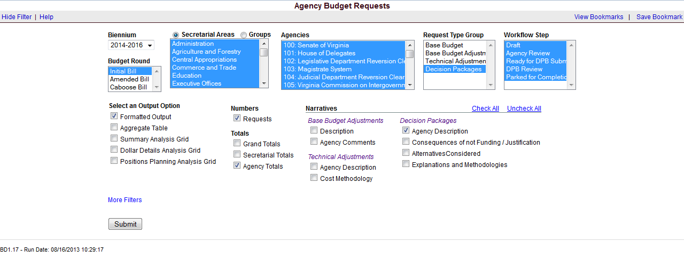

Decision Package Module Instructions
Performance Budgeting System

The decision package module is used for proposals to modify your agency's budget or to modify language in the Appropriation Act. These proposals will be in the form of either non-technical requests or technical adjustments. Non-technical decision packages involve new initiatives, changes in policy, or a significant budgetary impact. A technical adjustment is a proposal to modify your agency’s budget that does not involve changes in policy or significant budgetary impact. Technical adjustments are very similar to base adjustments to the extent that they are intended to reflect items such as the removal of one-time costs; the transfer of dollars or positions between programs or service areas, accounting for additional nongeneral fund revenues that involve no policy changes, and accounting for an increase in position level to reflect actions already approved administratively.

Each decision package should address and justify one budget action only. The action proposed in each decision package should be a discrete unit that can be evaluated on its own merit, independent of any other proposals. Under certain circumstances, several strategies or actions may be tightly related and cannot be viewed independently. If so, they may be grouped together in one decision package.

To access the decision package module, select “Decision Packages” within the “Decision Package sub-menu under the “Operating Budget” link on the Performance Budgeting System work tray / main screen.

If you have any questions of a policy nature, please contact your DPB budget analyst. If you experience technical issues with the Performance Budgeting System, please contact the VCCC help desk at vccc@vita.virginia.gov (make sure to indicate in the subject line that you are experiencing a Performance Budgeting system issue so that the ticket can be routed to the Performance Budgeting System help desk).
Decision Package Module Quick Guides

AGENCY ANALYST QUICK GUIDE
- Mouse over the Operating Budget functional area menu item and then mouse over Decision Packages. From the resulting dropdown menu, select Decision Packages and the Overview tab will appear.
- Complete the Overview tab as described in the Overview tab instructions.
- Complete the Narratives tab as described in the Narratives tab instructions.
- Complete the NGF Revenue Source tab as described in the NGF Revenue Source tab instructions. This tab only needs to be completed if there is an NGF Revenue impact for the decision package.
- Complete the Position Planning tab as described in the Position Planning tab instructions. This tab only needs to be completed if positions are requested or impacted by this request, including position reductions.
- Complete the Budget Detail tab as described in the Budget Detail tab instructions.
- Complete the Budget Summary tab as described in the Budget Summary tab instructions.
- Complete the Rate Adjustment tab as described in the Rate Adjustment tab instructions. Only complete this tab if you are a central service agency submitting a request for a rate adjustment.
- Click Submit and select the appropriate action from the available options.
  - Continue Working - Saves the decision package and returns the work item to the Available Work Items tab on the Work Tray for users with similar credentials to claim.
  - Submit for Agency Review - Submits the decision package to the next step in the workflow.
  - Void Document - Voids the decision package.

AGENCY REVIEWER QUICK GUIDE
NOTE: Ensure that all decision packages have been prioritized in the Decision Package Prioritization module. All decision packages must be prioritized before they can be submitted to DPB.
- Click on Available to be Claimed from the Work Tray.
- Select the Document Type filter and select Decision Package to filter on the decision packages.
- Click Claim next to a decision package that is ready for review. Once decision package is claimed, the Overview tab will appear.
- Review the Overview tab for completeness and accuracy. Refer to the DPB transmittal for any policy guidance.
- Click on the Budget Summary tab and review for completeness and accuracy. Refer to the DPB transmittal for any policy guidance.
- Click on the Narratives tab and review for completeness and accuracy. Refer to the DPB transmittal for any policy guidance.
- Click on the NGF Revenue Source tab and review for completeness and accuracy. Refer to the DPB transmittal for any policy guidance.
- Click on the Budget Detail tab and review for completeness and accuracy. Refer to the DPB transmittal for any policy guidance.
- Click on the Position Planning tab and review for completeness and accuracy. Refer to the DPB transmittal for any policy guidance.
- Click on the Rate Adjustment tab and review for completeness and accuracy. Refer to the DPB transmittal for any policy guidance.
- Click Submit and select the appropriate action from the available options.
  - Continue Review - Saves the decision package and returns the work item to the Available Work Items tab on the Work Tray for users with similar credentials to claim.
  - Ready For DPB Bulk Submit – Places the decision package in a batch to be submitted to DPB via the Decision Package Bulk Submit to DPB module. (Make sure you also rank the decision package in the Decision Package Prioritization module.)
  - Return for Further Data Entry - Returns the decision package to the data entry workflow step.
  - Void Document - Voids the decision package.

Overview Tab

Overview Tab Overview
The purpose of the Overview tab is to describe the decision package and select the level at which the budget details will be entered. Additionally, the ability to specify if new legislation or Appropriation Act language changes and attach a file related to those changes is provided.

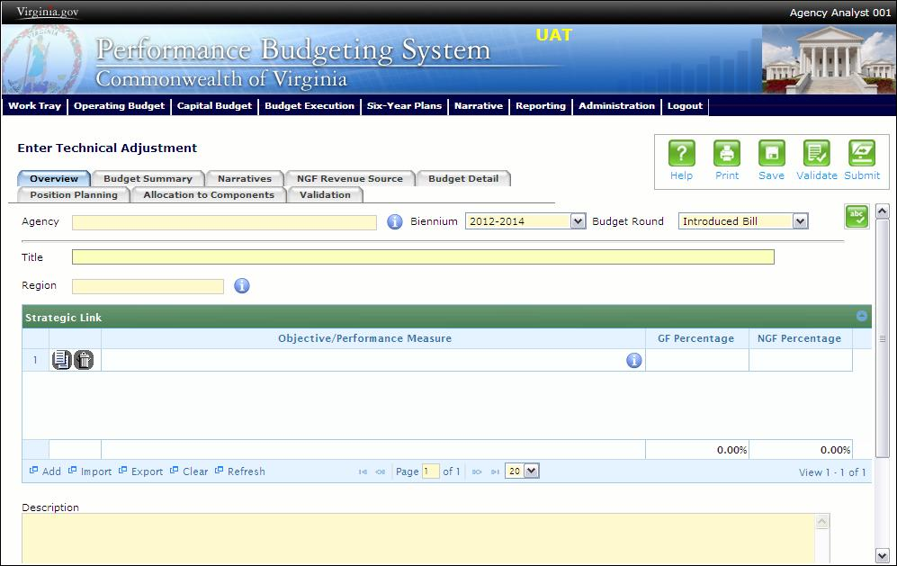
Overview Tab Instructions
- Click on the Overview tab.
- Select the Agency to which the decision package will be applied.
- Select the Biennium to which the decision package will be applied.
- Make sure the correct budget round is selected (initial budget, amended, or caboose).
- Enter the Title for the decision package.
Insert a short descriptive title. Remember that your title should begin with a verb such as increase, add, reduce, transfer, shift, expand, etc.

- Select the Category for the decision package.
Select the category that most closely defines the proposed strategy. The following list of categories represents typical request categories; if additional categories are needed they will be conveyed through the DPB transmittal.

  - Technical adjustments. This category is for technical or housekeeping adjustments that do not have an overall net general fund budget impact or do not involve policy decisions, such as to shift funds or positions between programs or service areas or to appropriate additional nongeneral fund revenue (such as a federal grant that is more than originally anticipated or will continue for an additional year).
  - Emergencies. The request is essential to prevent or eliminate an immediate threat to life, safety, health, or property.
  - Mandates. The request is necessary to meet the requirements of a state or federal law or a court order. (Note: The definition of mandate is restrictive.) Requirements of state or federal regulations are not considered mandates per se. If a regulation or legislation simply enables or authorizes an activity but does not require it, the activity is not considered a mandate. This category should be used only if there is absolutely no alternative but to fund the request. It is anticipated that very few, if any, requests will fall within this definition.
  - Unanticipated and unavoidable cost adjustments. This category is for increases or decreases in your agency's budget to reflect cost adjustments involving existing services or for adjustments to the rates charged by central service agencies for services used by other state agencies. (Note: This category is NOT for budget proposals involving a change in the scope of services or the way your agency delivers services or does business.)
  - Salary increases and regrades. Salary increases and regrades. This category is for salary increases due to position regrade/classification. (Note: This category is NOT for statewide salary increases or for new positions).
  - Caseload or workload adjustments. This category is for routine changes, either increases or decreases, in your agency?s budget to reflect cost adjustments involving changes in workloads or client loads. (Note: This category is NOT for budget proposals involving a change in the scope of services or the way your agency delivers services or does business.)
  - New general fund spending initiatives. This category is for proposing new general fund spending initiatives that have not received prior approval from the Governor or Cabinet Secretary.
  - Operational efficiencies and service reductions. This category is for cost savings or efficiency measures that your agency proposes to implement or for proposals that produce cost savings by reducing the services or scope of services delivered to your agency's customers. Examples include phasing out or eliminating certain administrative activities or positions, reducing or eliminating discretionary expenses (printing, travel, etc.), or decreasing or eliminating current services.
  - Reorganizations. This category is for proposals to transfer a program, service, or activity to another government entity (local, state, or federal), or to privatize. This category is for operational or organizational changes that will result in long-term cost-savings or benefits to the Commonwealth such as consolidating organizational units. This category also is for proposals that involve any agency reorganization that produces a need for additional agency resources (either funds or positions), or involves a policy issue. Examples include creating new organizational units or changing functional program units.
  - Information technology. This category is for proposals for information technology resources, including hardware, software (whether commercial packages or custom-developed), telecommunications equipment or services, and any related consulting, training, or support/maintenance services.
  - VITA rate change requests. This category is for requests for funding required by any change in VITA rates charged to agencies.
  - Other spending or initiatives. This category is for any other proposals for additional resources that will require new or expanded services.
  - Position level changes only. This category is for technical changes (increases or decreases) to position levels that have no other impact on appropriated amounts.
  - Appropriation Act language only. This category is for proposals to add, delete, or modify language in the Appropriation Act. Proposals in this category should have no impact on the appropriation amounts.

- Select a link for the decision package to an agency Objective/Measure in the Strategic Link grid. Additionally, apply a general fund percentage and nongeneral fund percentage and description of the link.
- Agencies may link a decision package to either a measure(s) or an objective, not both. If you opt to link to a measure or measures, then you should not also link to that objective. The percentages you apply to each measure would, when added up, effectively equal the objective total. Numbers must add up to a 100 percent. Objectives/measures are from agency submissions in Virginia Performs.
- Add rows to the Strategic Link grid as needed to specify objective/measure lines by using the button shown below.
- Select the Region of the state that the decision package most impacts. If it impacts more than one region, select "Multiple Regions".
- If applicable, select the statewide Enterprise Strategy that the decision package supports. It is not necessary to force a selection if the decision package does not clearly support any of the strategies listed.
- Enter the Agency Description for the decision package.
Summarize the actions your agency proposes to take with the requested dollars or positions. If the decision package is for language only, explain what the language will allow the agency to do. In addition, provide detailed information to indicate the need for the proposed service. Cite quantitative data wherever possible.
- Check Will new legislation be required as a result of this request? if new legislation is required as a result of the decision package.
- Check Is Appropriation Act Language required as part of this request? if Appropriation Act language is required for the decision package.
- Upload any supporting documentation for the decision package by clicking Browse, selecting the file to be uploaded, and clicking the Upload button.
Note: This will be required if either the check box about new legislation or new Appropriation Act Language is checked. Changes will be shown using the appropriate italics or strike-through.
- Check Show Cost Code and/or Show Project Code if the budget details for the decision package will be entered at the cost code level, operating project code level, or both.

Narratives Tab

Narratives Tab Overview
The purpose of the Narratives tab is to capture the justification for the decision package, including justification for any rate adjustments. Remember, quality is important! Decision-makers may have only your narrative as a basis for evaluating your agency's proposal. You will need to be as thorough as possible to explain what the proposal involves and why it should be funded.

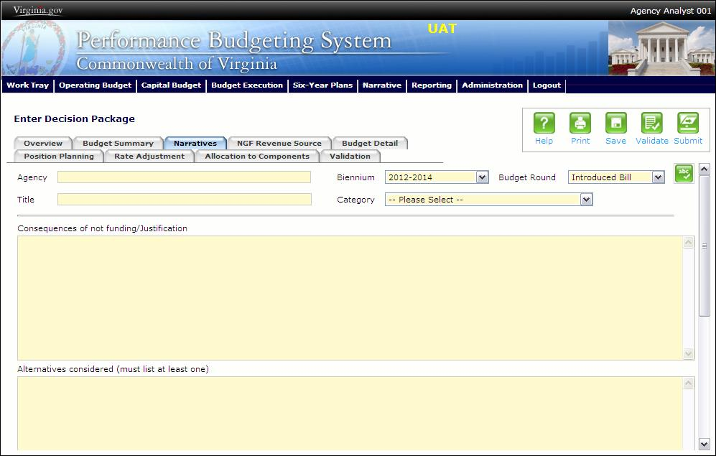
Narratives Tab Instructions
- Click on the Narratives tab.
- Enter the Consequences of not funding/justification.
Indicate the consequences you expect if your proposal is not approved. Detail how not funding this action will impact the agency's performance measures and targets.
- Enter the Alternatives considered (must list at least one).
Indicate any other alternatives you considered for accomplishing the objectives of the request and why you selected the proposed action. Briefly list the pros and cons of each alternative.
- Enter the Explanations and Methodologies.
Explain how you calculated your request and any assumptions used, the methodology used. Enter as much detail as necessary to fully explain the methodologies used.
- Attach any Supporting Documentation to further justify the need for the decision package.

Budget Summary Tab

Budget Summary Tab Overview
The purpose of the Budget Summary tab is to capture the high level general fund (GF) and nongeneral fund (NGF) six-year budget impact for the decision package. The information on this tab can be entered before the Budget Detail tab is completed as a placeholder if an agency is unsure if they are going to submit a decision package to DPB. If the Total Services grid on the Budget Detail tab has already been entered, the Summarize Budget functionality can be used to populate the first two years of the Summary of Costs and Positions grid based upon the data entered in the Total Services grid.
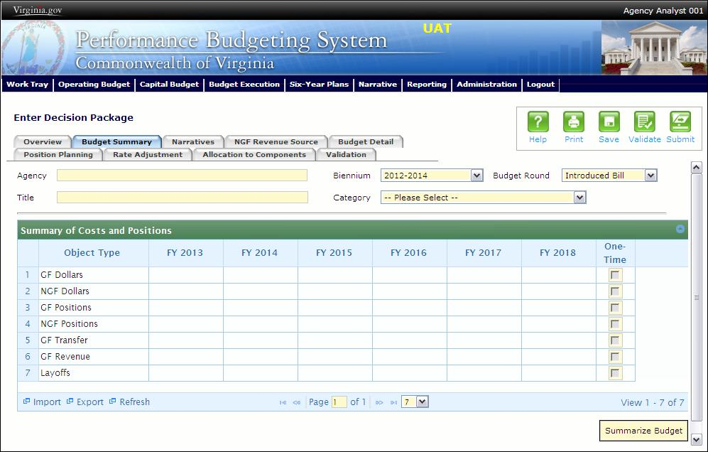
Budget Summary Tab Instructions
- Click on the Budget Summary tab.
- If the data has already been entered in the Total Services grid on the Budget Detail tab, click Summarize Budget. This will populate the GF and NGF data for the first two years in the Summary of Costs and Positions grid based upon the data entered in the Total Services grid on the Budget Detail tab.

- Enter the out-year impact for the decision package in the Summary of Costs and Positions grid and, if entering Budget Summary first, enter data for the two years of the biennium for which work is currently being completed. Agencies must enter data for all six years, even if the amount is zero.
- If the decision package results in a change in general fund resources/revenue, enter the amount in the applicable row at the bottom of the summary grid. "GF Transfer" is for nongeneral fund cash transfers to the general fund, "GF Revenue" is for changes in general fund revenue coming in to the Commonwealth, and "Additions to Balance" is for the reversion of general fund balances from agencies to the General Fund.

Budget Detail Tab

Budget Detail Tab Overview
The purpose of the Budget Detail tab is to capture the budget details, line by line, for the decision package. A user will be required to enter the program (including service area), fund, subobject, and FY 20XX and 20XX dollars for each budget line associated with the decision package. If a user specifies that they will be budgeting at the cost code and/or project code levels, then they will be allowed to enter this level of detail when entering the budget details.

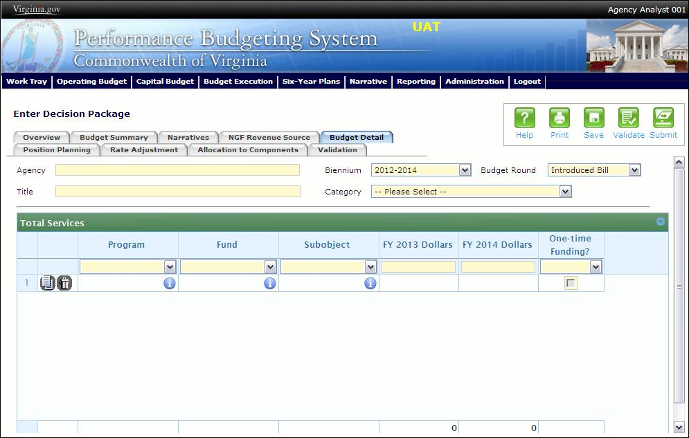
Budget Detail Tab Instructions
- Click on the Budget Detail tab.
- If applicable, confirm the personal services data that populated the Total Services grid from the Position Planning tab is correct. If the data is incorrect, return to the Position Planning tab to make corrections and then repopulate the data as described in the Position Planning tab instructions.
- In the Total Services grid, enter the Program (program, service area and component), Fund, and Subobject for each nonpersonal services budget line. Additionally, if applicable for the budget line, enter the Cost Code and/or Project Code.
- Enter the FY 20XX Dollars for the budget line.
- In the Total Services grid, if the budget line specified is one-time funding, then check the One-time Funding checkbox. If a budget line contains a mix of one-time and ongoing funding, create a separate line for the one-time amount and another for the ongoing funding requirements.
- Add rows to the Total Services grid as needed to specify multiple nonpersonal services budget lines by using the button.

Position Planning Tab

Position Planning Tab Overview
The purpose of the Position Planning tab is to capture position changes associated with the decision package. Once the positions are entered, the personal services budget can be automatically calculated and the resulting budget data can be used to populate the personal services subobjects in the Total Services grid on the Budget Detail tab. The position planning tab allows you to enter authorized position and salary information by either position or role which will in turn allow you to calculate the overall cost of new positions to include compensation and benefits. Alternatively, you may enter just the authorized position information by selecting the "Not Budgeting by Role or Position" option.

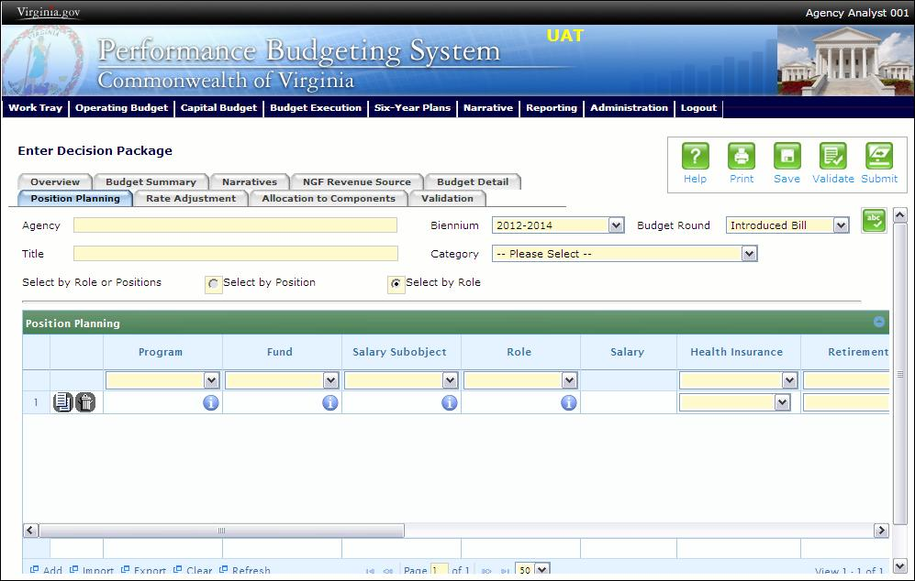

Position Planning Tab Instructions

Position Planning for Authorized Positions Only
Use this method if you do not need to calculate the cost of positions in the Performance Budgeting System and only want to record the authorized position level associated with the base adjustment.
- Click on the Position Planning tab.
- Check the Not Budgeting by Position or Role checkbox.
- In the Position Planning grid, enter the total number of positions for the Agency for both the first year and second years of the biennium in the FY 20XX Positions cells.
- Add rows to the Position Planning grid, by clicking the Add button in the lower left corner of the grid as needed.
- Authorized positions can also be uploaded from an .xls file.

Position Planning by Role
Use this method if you would like to use the capabilities of the Performance Budgeting System to assist in the calculation of the dollar costs of positions associated with the base adjustment.
- Click on the Position Planning tab.
- Select the Role radio button.
- In the Position Planning grid, enter or edit the Program, Fund, and Subobject for a role. Additionally, if applicable for the role, enter the Cost Code and/or Project Code.
- Select or edit the Role.
Enter the proper role title for the position you are requesting. Please contact the Department of Human Resource Management (DHRM), the DHRM website, or your agency human resource department for this proper role title.
- Enter or edit the Salary for the selected role.
Enter the base salary for the position being requested. Do not include any benefit amounts. The requested amount must be within salary range and should be based on starting salaries for recent hires in this role.
- Select or edit the Health Insurance for the role.
Select a health premium. You can select the statewide average, or the actual employers premium for single, employee plus one, and family coverage.
- Select or edit the Retirement for the role.
Select the retirement type for the position: regular VRS, VaLORS, SPORS, judges' retirement, or defined contribution.
- Enter or edit the number of pay periods for the role for the first year of the biennium in the FY 20XX Pay Periods cell if the role is valid for the first year of the biennium.
- Enter or edit the number of positions allocated to the specified role for the first year of the biennium in the FY 20XX Positions cell if the role is valid for the first year of the biennium.
- Enter or edit the FY 20XX Pay Periods and FY 20XX Positions, where 20XX is the second year of the biennium. Data will only be entered for the second year of the biennium if the role is valid for the second year of the biennium.
- Add rows to the Position Planning grid, by clicking the Add button in the lower left corner of the grid as needed.
- Once all roles have been added to the Position Planning grid, click the Calculate button to calculate the dollar impact for both years of the biennium for the specified roles. This calculation is based upon the data entered for each role.
- Confirm the calculation of the budget for both the first and second years of the biennium FY 20XX Budget. If the amounts are not correct, edit the values entered for a role and recalculate the budget for that role.
- Once the budget for both years of the biennium for each role is satisfactory, click the Populate Total Services button to calculate the personal services amounts for the Budget Details tab based upon the data entered in the Position Planning grid.

Position Planning by Position
Use this method if you would like to use the capabilities of the Performance Budgeting System to assist in the calculation of the dollar costs of positions associated with the base adjustment.
- Click on the Position Planning tab.
- Select the Position radio button.
- In the Position Planning grid, enter or edit the Program, Fund, and Subobject for the role. Additionally, if applicable for the position, enter the Cost Code and/or Project Code.
- Enter or edit the Position Title.
Enter the proper position title for the position you are requesting. Please contact the Department of Human Resource Management (DHRM), the DHRM website, or your agency human resource department for this proper title.
- Enter or edit the Salary for the selected position.
Enter the base salary for the position being requested. Do not include any benefit amounts. The requested amount must be within salary range and should be based on starting salaries for recent hires in this position.
- Select or edit the Health Insurance for the position.
Select a health premium. You can select the statewide average, or the actual employers premium for single, employee plus one, and family coverage.
- Select or edit the Retirement for the position.
Select the retirement type for the position: regular VRS, VaLORS, SPORS, judges'retirement, or defined contribution.
- Enter the number of pay periods for the position for the first year of the biennium in the FY 20XX Pay Periods cell if the position is valid for the first year of the biennium.
- Enter or edit the number of positions allocated to the specified position for the first year of the biennium in the FY 20XX Positions cell if the position is valid for the first year of the biennium.
- Enter or edit the FY 20XX Pay Periods and FY 20XX Positions, where 20XX is the second year of the biennium. Data will only be entered for the second year of the biennium if the position is valid for the second year of the biennium.
- Add rows to the Position Planning grid, by clicking the Add button in the lower left corner of the grid as needed.
- Once all roles have been added to the Position Planning grid, click the Calculate button to calculate the dollar impact for both years of the biennium for the specified positions. This calculation is based upon the data entered for each.
- Confirm the calculation of the budget for both the first and second years of the biennium FY 20XX Budget. If the amounts are not correct, edit the values entered for one or more positions and recalculate the budget for that those positions by repeating step 12.
- Once the budget for both years of the biennium for each position is satisfactory, click the Populate Total Services button to calculate the personal services amounts for the Budget Details tab based upon the data entered in the Position Planning grid.

Allocation Across Components

Components Overview
The purpose of the Allocation Across Components tab is to capture the budget details for each budgetary component by program and fund/fund detail. A discrete piece of an agency’s budget that further breaks down its activities or services, components contribute to the accomplishment of an agency’s mission.

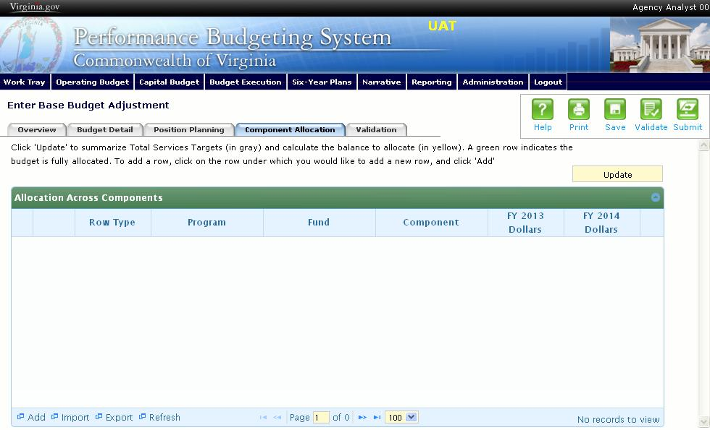
Components Instructions
- Click on the Component Allocation tab.
- Click on the "update" button. This will populate the Component Allocation tab with your budget by program and fund/fund detail as allocated in the base budget total services grid. These lines will appear in the shaded grey rows. The balance to be allocated by component will be in the shaded yellow rows.
- Click on the balance row where you would like to add a new row, and click "Add." In order to select the balance row properly, click the program field in the balance row. Keep adding rows until your budget is fully allocated by component.
- Click the "update" button to check the balance remaining to be allocated. A green shaded row indicates that your budget is fully allocated.
- Components can also be imported into the grid. The best method for this is to export the grid after you have clicked "update." Add component records in the Excel file using the proper ID numbers, and re-import the data set. After you re-import you will need to click "update" again.

NGF Revenue Source Tab

NGF Revenue Source Overview
The purpose of the NGF Revenue Source tab is to capture a six-year estimate of any NGF Revenues that will be generated from the decision package. The revenue estimate should include any nongeneral fund revenue that the agency will collect, receive from another agency, or send to another agency based upon the implementation of the decision package. This tab should only be completed if there is a nongeneral fund request/impact. This is over and above amounts in the six-year nongeneral revenue fund estimates module.

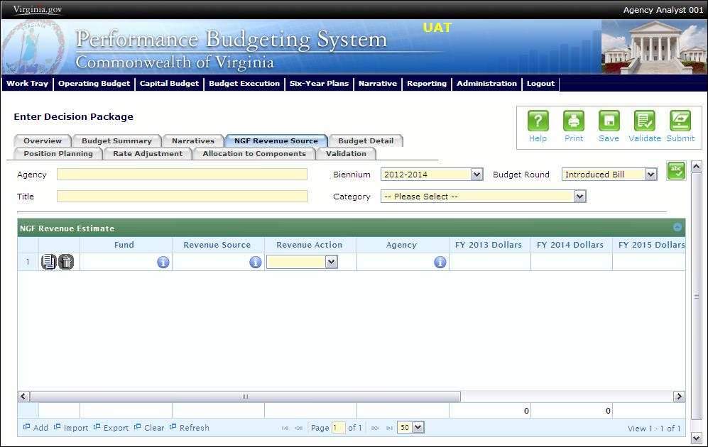
NGF Revenue Source Instructions
- Click on the NGF Revenue Source tab
- In the NGF Revenue Estimate grid, enter the fund and revenue source code associated with the nongeneral fund revenue.
- In the NGF Revenue Estimate grid, select the Revenue Action (send to or receive from) and Agency (pass through or may be blank) associated with that action if applicable.
- In the NGF Revenue Estimate grid, enter an nongeneral fund revenue estimate for six years in the columns labeled with the out-years, FY 20XX Dollars.
- In the NGF Revenue Estimate grid, click on the Methodology cell for revenue source that is currently being estimated. In the popup window that appears, enter the methodology used to make the estimate.
- Add rows to the NGF Revenue Estimate grid as needed to specify multiple nongeneral revenue sources for the decision package by using the button shown below.

Rate Adjustment Tab

Rate Adjustment Tab Overview
The purpose of the Rate Adjustment tab is only for central service agencies that anticipate a change in their assessed rates for internal service fund services they provide to other state government agencies. A spreadsheet showing the impact of the proposed rate change, by agency, must be attached to the Narratives tab.

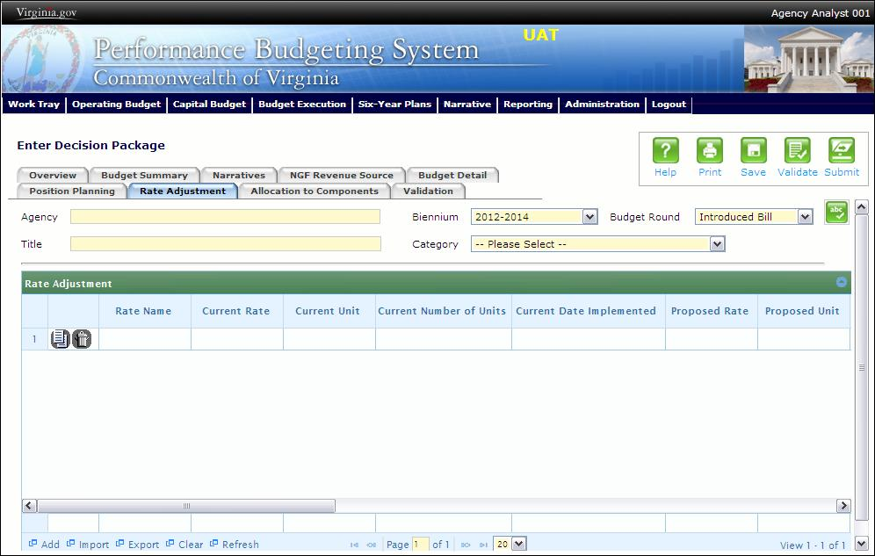
Rate Adjustment Tab Instructions
- Click on the Rate Adjustment tab.
- In the Rate Adjustment grid, enter a Rate Name for rate that will be adjusted.
Enter the official name/title of the rate as it is commonly known.
- In the Rate Adjustment grid, enter the Current Rate, Current Unit, Current Number of Units, and the most Current Date Implemented for the rate that will be adjusted.
- In the Rate Adjustment grid, enter the Proposed Rate, Proposed Unit, Proposed Number of Units, and the Proposed Effective Date for the rate that will be adjusted.
- Enter the FY 20XX Revenue Impact for the rate that will be adjusted, where XX is the first and second years of the biennium and the four out-years.
- Enter the Rationale for Rate Change for the rate that will be adjusted. Associated/required narrative fields can be found on the narratives tab.
Describe the anticipated results or objectives your agency expects to accomplish if the proposed rate adjustment is approved.

Decision Package Prioritization Instructions
Performance Budgeting System
Decision Package Prioritization Overview
The purpose of the Decision Package Prioritization module is to allow an agency to rank decision packages prior to submitting them to DPB. The rank and biennial general fund and nongeneral fund impact is displayed for each decision package. An Agency Analyst or an Agency Reviewer may drag and drop decision packages to create a new decision package ranking for an agency. Decision packages must be ranked prior to submission to DPB.
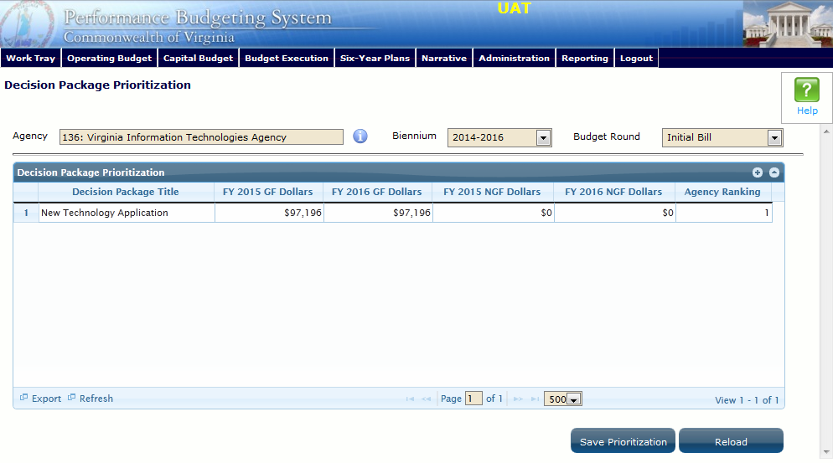
Decision Package Prioritization Instructions
- Click on the Filter by Agency and select an agency to rank the decision packages for an agency.
- Confirm the Biennium and budget round for the decision packages.
- To change the ranking of a decision package in the Decision Package Prioritization grid, click and hold on a decision package that should have a different rank. Move the decision package up or down using the mouse to insert the decision package at a higher or lower ranking. Then, release the mouse. The rankings of all decision packages will then be automatically adjusted. Re-rank as many decision packages as necessary until the desired ranking is achieved.
- While working, if you would like to reload the rankings as they appeared upon the last save, click the Reload button.
- Once the desired ranking is achieved, click the Save Prioritization button to save the decision package ranking for an agency.

Decision Package Bulk Submit Instructions
Performance Budgeting System
Bulk Submit Overview
The purpose of the Decision Package Bulk Submit to DPB module is to allow an agency to submit all their decision packages to DPB at once.
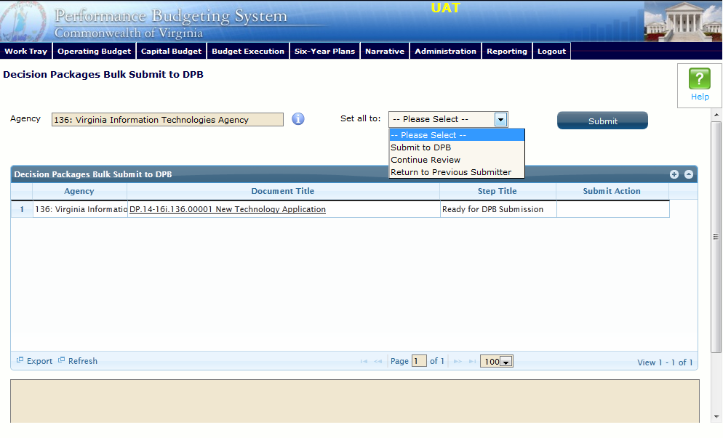
Bulk Submit Instructions
- To ensure that all requests are accounted for, look at the Document Title column to review the base budget adjustments.
- Confirm that the Step Title and State fields are correct for each of the base budget adjustments.
- To bulk manage the submit action, click the Set all to dropdown and select the submit action that the requests require: Submit to DPB, Continue Review, or Return to Previous Submitter. If submitting to DPB, all requests must be set to Submit to DPB. The submit actions correspond to the submit actions in the Decision Package module documentation.
- Click the Submit button. A message will display in the text box below the submit button to alert you that the submission was successful. If you receive a message that one or more work items could not be submitted, you should navigate to the work tray and open the work items to determine if they are failing validation rules for some reason.

